Xwatch Safety Solutions Case Study

Xwatch Safety Solutions based in South Wales raise the bar for safety solutions in all environments, including construction, mining and transportation.
It is crucial when operating heavy mobile machinery that all the relevant safety rules are adhered to and vital that the person in charge keeps up to date with the changes to rules and regulations. That is why when Dan Leaney, sales and operations director at Xwatch, wanted the best performance for their products and after 12 months of extensive testing they settled with their trusted quality German solution provider, ifm electronic Ltd, whose track record of delivering durable industrial grade products spans over 50 years.
Xwatch have launched their XW Series with Ifm products at the core of all the solutions. Flexibility, performance, and reliability are key. Daniel believes this “Has revolutionised the safety market”. Daniel speaks very highly of ifm and says that not only is it the product that they love, but also the support that they get from their team of engineers which he believes is second to none. He says that “Xwatch would not exist without Ifm”. Daniel said they wanted to work with a global company who would support and work with the processes within Xwatch and with the ability to grow with the future demand for the Xwatch product range. Reliable and future proof hardware backed by excellent support is critical. Daniel believes they have found that in ifm and says they do not just see them as a supplier, but as a partner who is integral to their business.
Xwatch recently had the XW series of products assessed by TUV Rheinland, and subsequently approved by Network Rail. Xwatch is the only provider, in their market, to have this level of certification. ifm hardware, with its product certification, played a vital role in meeting the standards required.

With height control, slew control, and stability monitoring, the XW series is the leading off highway construction safety solution available worldwide. With products selected from the ifm BasicSystem range, Xwatch provide systems that are swift to install, easy to use, dependable, and easy to upgrade. The flexibility of the Basic System components allows for rapid customisation when required.
Looking forward, Xwatch have projects under development, again built on ifm components. These are complex control systems and as SIL2/PLd are requirements use the CR7xxS safety controller and CR105x HMI. As the Xwatch reputation has grown opportunities to integrate with third party systems, and at OEM level, are being evaluated.

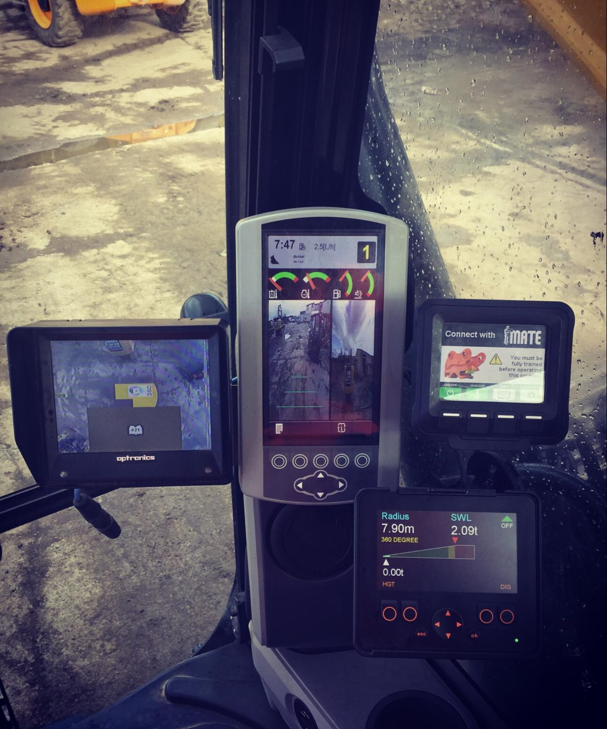Image 1: This is an XW2 height and RCI system fitted to a JCB. It monitors the height for working underneath power/phone cables or anywhere that the customer doesn’t want to hit. Xwatch also use ifm’s pressure transducers PT9900 (two on each machine) which allows them to calculate the lifting pressure of the main boom for the RCI.
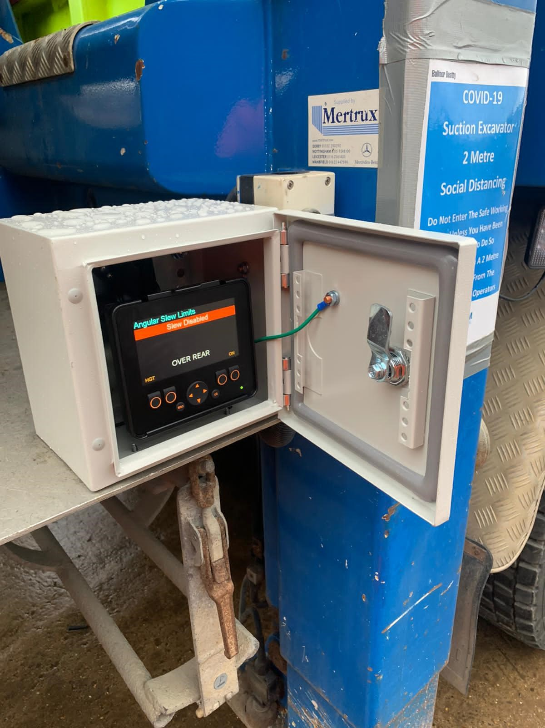
Image 2: This is a special application for a suction excavator truck called a VacEx built for Balfour Beatty. It monitors both height and slew and was fitted by Road Rail plant, an Xwatch dealer.

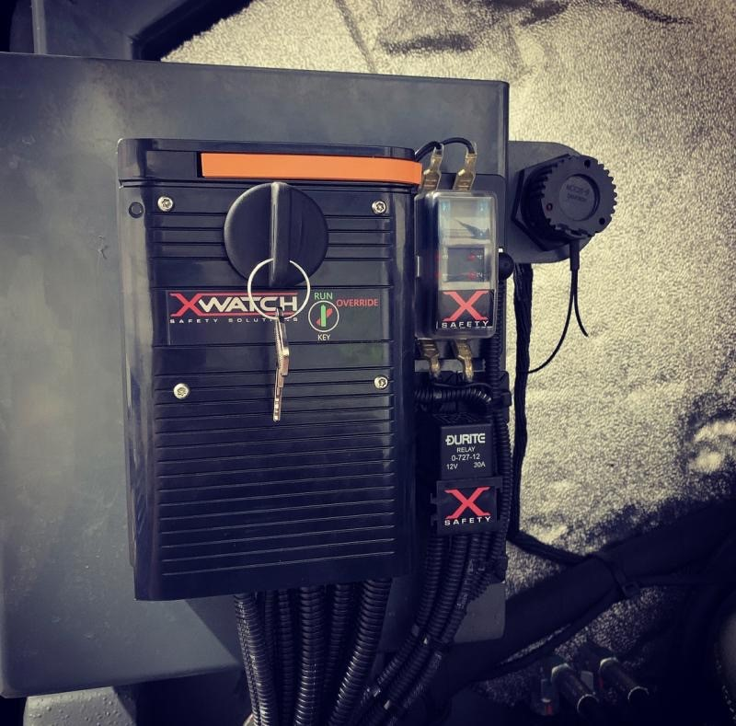
Image 3: ifm’s CRO403 fitted with Xwatch own key switch override. Fitted to the cover that allows the Xwatch to be overridden in case of a system failed or damage. Xwatch have a failed rate of less than 0.5% largely due to the reliability of the ifm hardware

