JAMES JONES VIBRATION CASE HISTORY

Through five generations of family ownership, James Jones has manufactured the widest range of sawn timber products including carcassing, fencing, palletwood, heavy sections and, more recently, engineered timber products and is now regarded as one of the most innovative and efficient timber processors in Europe.
Due to the demand in their products, keeping production running is a major priority for them. For this reason they turned to trusty German manufacturer, ifm electronic Ltd, when they decided to invest in using VSE vibration modules and sensors to help them detect faults before they become serious and also to ensure production uptime.
Due to the bearing frequency trends increasing over time on the unit, it was decided to remove the unit from service and install a new motor.
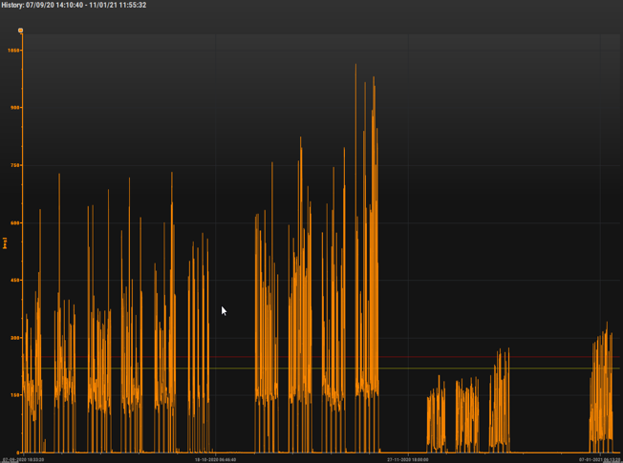
However as can be seen in the trend, the bearing frequency levels quickly started to increase. So more in-depth analysis would be required.

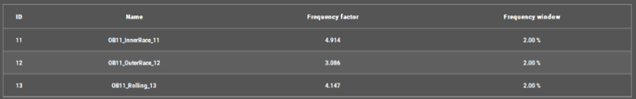Knowing the bearing frequencies enabled an accurate diagnosis of the fault, which shows as an outer race defect.

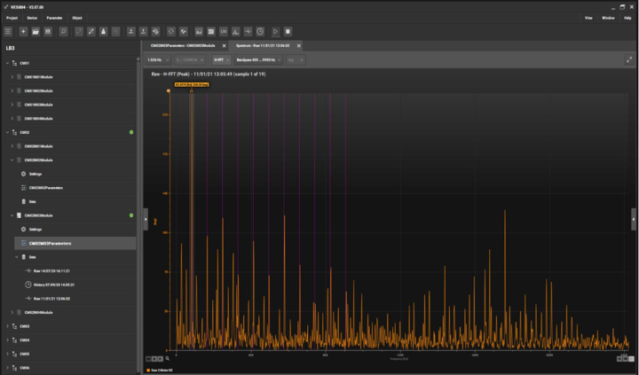
The level of activity was surprising as the unit had not been in operation for very long. It was decided to see what the rate of change on the levels would be over the next few days.
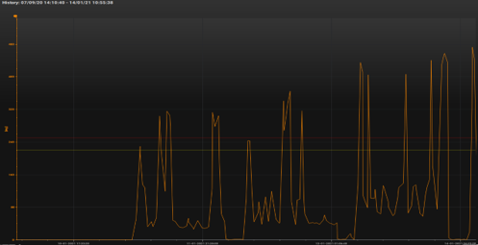
Due to the large increase in the bearing levels over three days, it was decided to replace the drive end bearing.

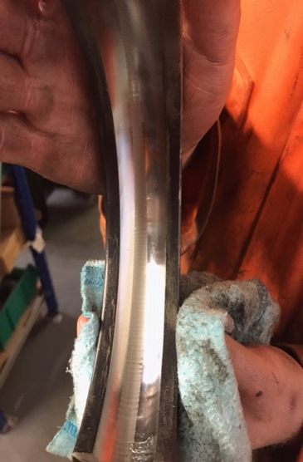
On inspection of the bearing, the outer race damage is visible, the cause is electrical fluting.
Electrical fluting occurs when a current is passed through the motor bearing instead of a grounded source. PWM (Pulse Width Modulated) drive switching frequencies result in undesirable motor shaft currents, a side effect that causes bearing damage within the motor through pitting and fluting. The audible noise generated by the damaged bearings increases and motor failure soon follows.

Return On Investment and Savings
Monitoring cost per asset = 1 x VSE100, 4 x VSA001 and cables. Total cost £1,324
Cost of training to use the system and analysis Total cost £2,060
Cost of new motor = £1,200
Length of time to replace/repair the motor = 3 hours
Cost of lost production = £18,000
Man hours saved = 9 hours as 3 men would be needed.
So far 3 bearing faults have been detected.
Total savings so far £57,600 and 27 man hours saved.

