Press release wpi 597 / 0318  Hannover Messe Preview 2018  New IO-Link master modules with IoT core  Essen, March 2018 – Paving the way towards Industry 4.0 is one of ifm's main concerns. At this year's Hannover Messe, ifm will present two new series of their IO-Link master modules. With their integrated IoT core, the new modules simplify the connectivity required for Industry 4.0 applications. This also reflects this year's motto of the trade fair: Integrated Industry – Connect and Collaborate.  ifm uses the digital protocol IO-Link to ensure fast communication from the sensors via the control level up to the ERP level and into the cloud. As IO-Link not only enables the transfer of measured values, but also the transfer of status information from the sensor and configuration data to the sensor, it is a digital protocol that fulfils all requirements to realise extensive connectivity. The IO-Link master modules of the DataLine and CabinetLine series are supplemented by further versions and have an integrated IoT core that makes communication even easier. Besides the IO-Link interface and the corresponding fieldbus interface, the new modules have an additional IoT Ethernet socket enabling the connection to IT systems. The automation and IT nets can be separated; any interference of the fieldbus level caused by the IT level is prevented. The IO-Link master has an own IP address and offers "plug & play" IO-Link connectivity due to its TCP/IP JSON interface. As the system is open, the connection to the ERP level can be realised with any system – which constitutes a further advantage of this solution. The IO-Link master modules of the DataLine series comply with protection rating IP65, IP67 and IP69K and are suitable for use in the field. The CabinetLine series with protection rating IP20 on the other hand is intended for installation in the control cabinet. Both versions are available with the fieldbus systems Ethercat, Profinet and Ethernet/IP. Typical applications for the new IO-Link master modules are Industry 4.0 applications, such as condition-based maintenance or energy data management.  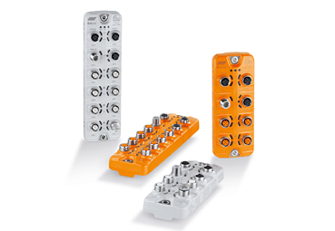 wpi_597_print.jpg Ready for use in no time: New IO-Link master modules with IoT core.  For text / pictures please go to: www.ifm.com/de/presse-technik | Contact  ifm electronic gmbh  Friedrichstr. 1  45128 Essen  www.ifm.com  Tel.: 0201 / 24 22-0  Fax: 0201 / 24 22-1200  Email: presse@ifm.com  Simone Felderhoff  Corporate communications  Tel.: 0201 / 24 22 1411  Email: simone.felderhoff@ifm.com

